11th Segny-Monte Carlo Rally, Programme

Thursday 29 may – Sunday 1 june 2003

Day 2, Friday 30 may

Afternoon, 14.00-18.00
14.00-16.00 | Treasure hunt in Gordes.
16.00-18.00 | Picture hunt to hotel.

Treasure hunt in Gordes

- What was Pol Mara’s real name?

- Buy some tapenade, keep the receipt.
- Find “Marianne”. Become a member, and keep your membership card as proof.
- When was the institution founded?

- Draw a “borie”.

- What is a “mas”?

- Visit the Caves St. Firmin, keep the ticket as proof.
- On which pilgrimage road are we?

- What seafood bears this name?

- Find one and take a picture to prove it.
- Where is the catalogue des dames de la congregation?

Each correctly answered question will earn your team 2 points. You have plenty of time to enjoy Gordes, one of the most beautiful villages in France. Leave for the picture hunt around 16.00 hrs.

Picture Hunt to the hotel

Try to find the way to the hotel by following the pictures. You will get 20 points for finding the hotel, 0 points if you open the panic envelope.
There are no questions, just penalty points for being late.

You should arrive at the hotel before 18.00 hrs. Penalty points for arriving late will be deducted for each multiple of 5 minutes (n), as yesterday, according to the formula n**2.

- 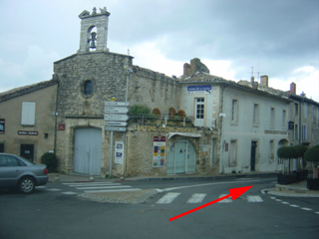

- 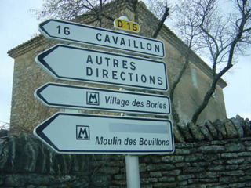
- 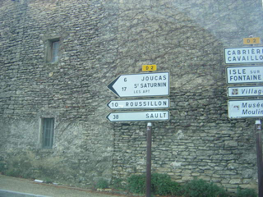

- 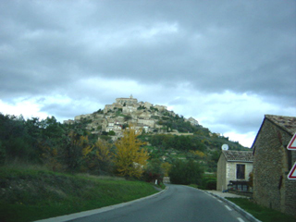
- 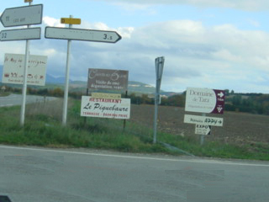

- 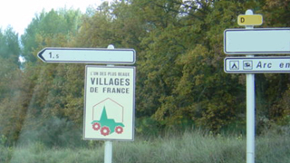
- 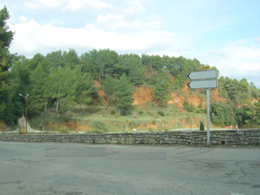

- 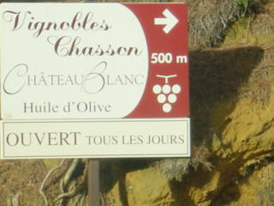
- 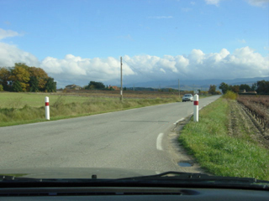

- 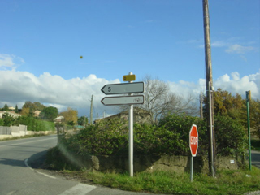
- 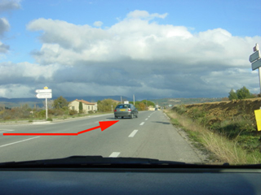

- 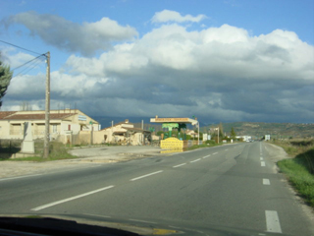
- 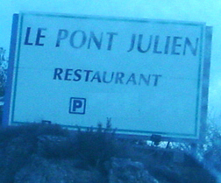

- 
- 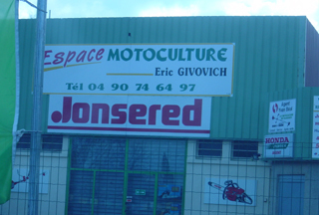

- 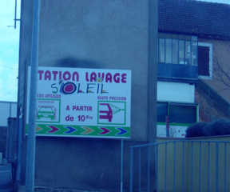
- 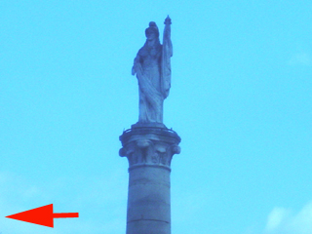

- 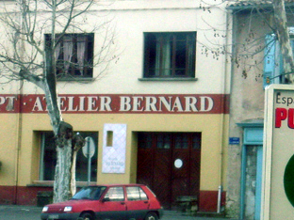

- 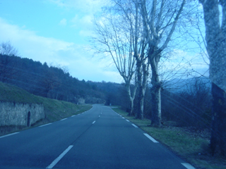

- 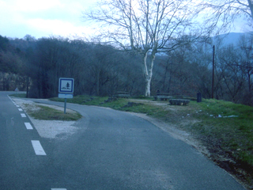
- 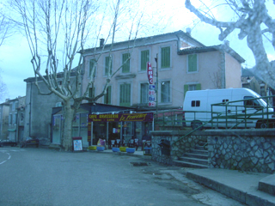

- 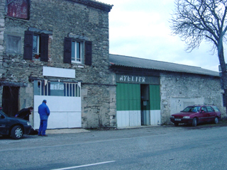
- 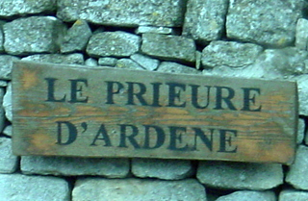

- 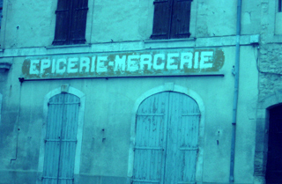
- 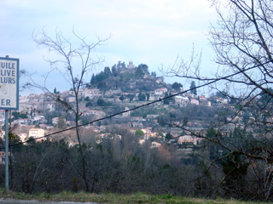

- 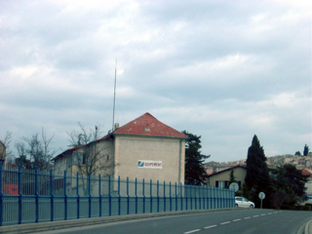
- 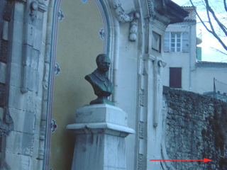

- 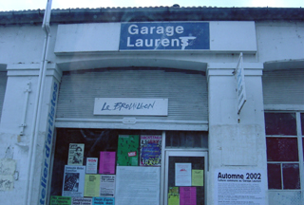
- 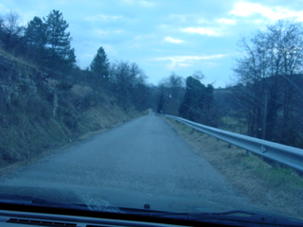

- 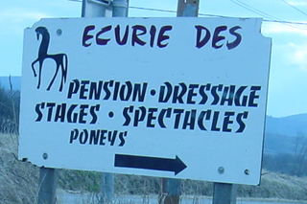
- 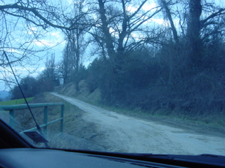

- 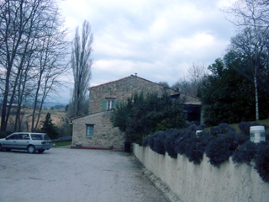
- 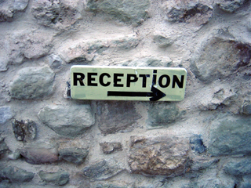

Congratulations, you made it!

